**6.2Screen displaying the menus**

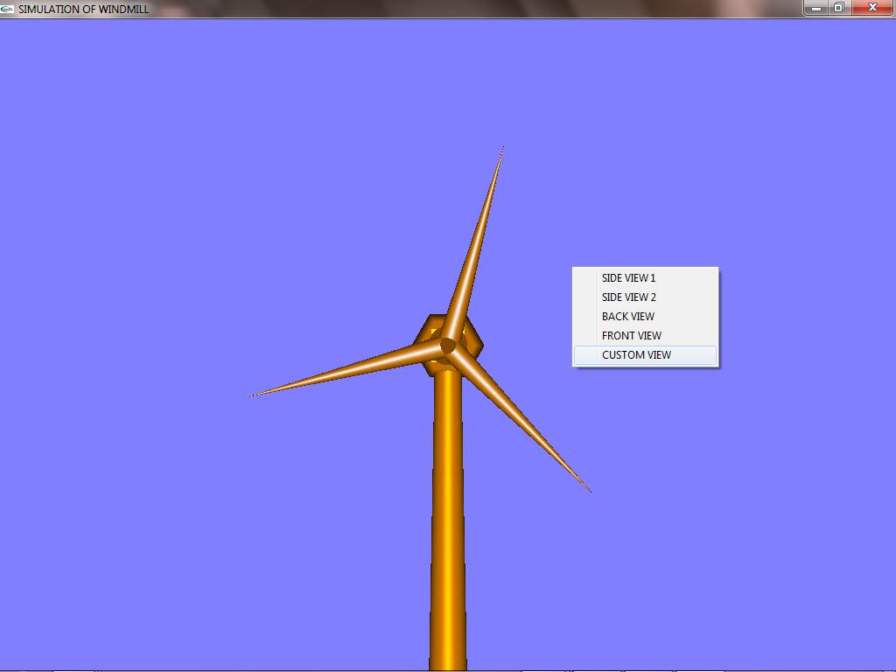

Fig 6.2: Screen displaying the menus.

The above diagram shows the snapshothaving options such as Data_Structuresand displaying the menu which consists of.:-

* Side View 1
* Side View 2
* Back View
* Front View
* Custom View

**6.3 Back View**

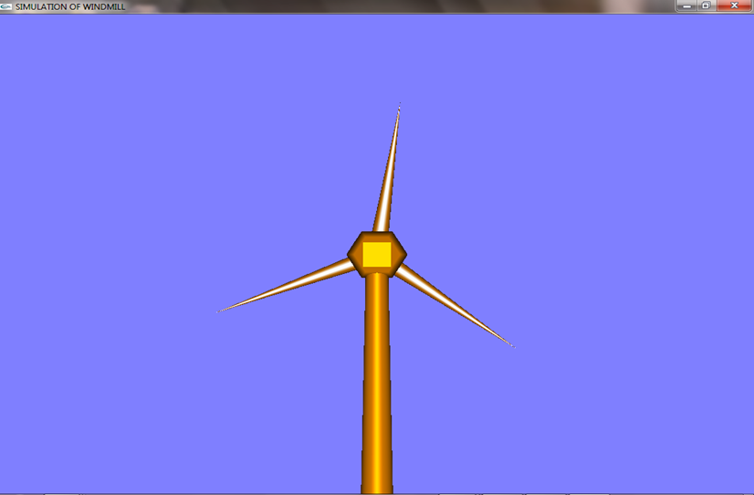

Fig 6.3: Back View

The above diagram shows the snapshot about the option of Back View , in which the Back View of the Windmill structure is displayed .

.

**6.4 Side View 1**

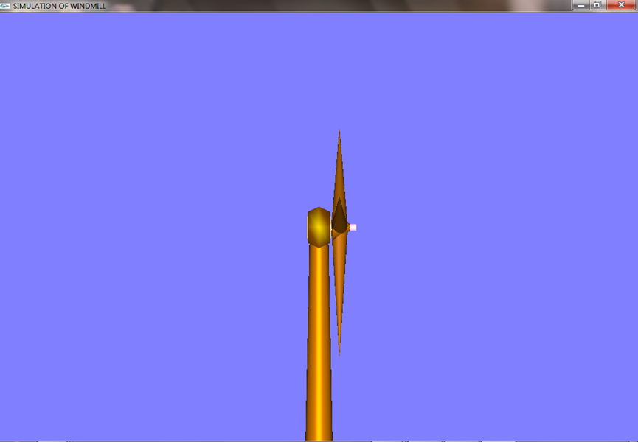

Fig 6.4: Side View 1

The above diagram shows the snapshot about the option of Back View , in which the Side View of the Windmill structure is displayed

**6.5 Speed Tracking on Mouse Clicks**

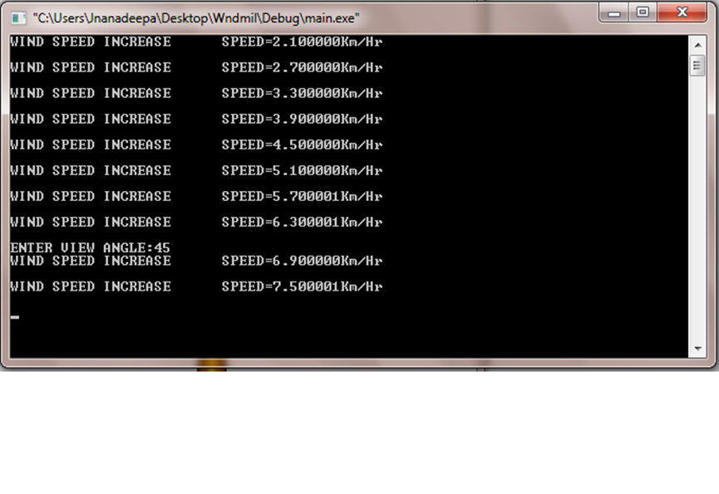Fig 6.5: Speed tracking using Mouse Clicks

The above diagram shows the snapshot about the simulation of the windmill, When the wheel of the windmill is made to rotate using the Left and Right Button of the mouse.

When the Left Button of the mouse is clicked, it starts rotating and on further clicks the speed of the rotation increases.

When the Right Button of the mouse is clicked, the rotation speed decreases and finally comes to halt.

**6.6 Free Movement using Keys**

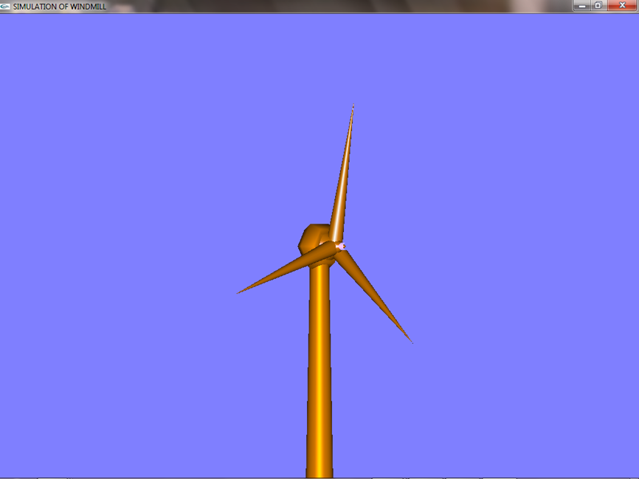

Fig 6.6: Free Movement using Keys

The above diagram shows the snapshot about free movement of the Windmill structure using the keys. The Right Arrow key is used to rotate the angle of the windmill structure clockwise, whereas the Left Arrow Key is used to rotate the angle of windmill structure anti-clockwise.

.